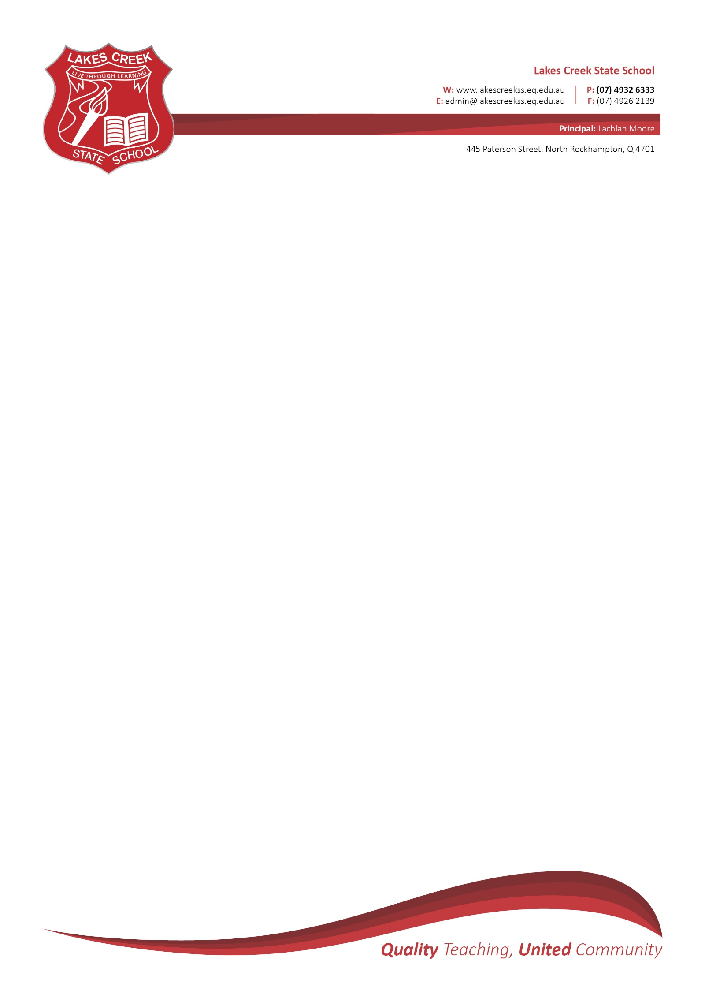

***Year 2/3 2025 Booklist***

|  |  |  |
| --- | --- | --- |
| NO. Of Items | ***Books and Folders*** | Tick |
| 3 | Scrapbooks – 72 Pages |  |
| 6 | A4 Exercise Books – 96 Pages – **(no blue lines)**  **Year 2 or Year 3 lines only (depends on year level)** |  |
| 1 | A4 Maths Grid – 96 Pages - ***10mm Square*** Only |  |
| 4 | Plastic Document Wallet – Music, Reading, Religion, Homework |  |
|  | ***Stationery and Essentials*** |  |
| 2 | Box of Tissues |  |
| 1 | 12 pack of Felt Pens |  |
| 2 | Packs of Coloured Pencils – Long |  |
| 1 | Highlighters (pack of 4) |  |
| 2 x 20 (Box) | Pencil HB – No Pacers |  |
| 1 | Pencil Sharpeners – ***Barrel*** |  |
| 1 | Long Thin Pencil Case (For Basic Stationary) |  |
| 6 | White Erasers **(2 for use in Art/Music)** |  |
| 1 | Headphones – no ear buds – clearly named |  |
| 6 | Large Glue Sticks |  |
| 3 | Reams of White Paper |  |
| 1 | Ruler **(Wooden)** 30 cm **Not 40 cm** |  |
| 1 | Scissors 20cm |  |
| 12 | Whiteboard Markers + Whiteboard Duster (for student use on show me boards – not Teacher use) |  |
| 1 | Library Bag |  |

All supplies need to be provided at the start of the year and **will need to be topped up during the year as needed.**

***PLEASE ENSURE YOU NAME ALL SCHOOL RESOURCES WITH YOUR CHILDS NAME!***